Project decision AI-Driven Clinical Decision Support: Enhancing Disease Diagnosis Exploiting Patients Similarity

Analysis

Health data -> physicians make mistakes when diagnosing -> with the help of AI/ML -> help diagnosis -> systems like CDS -> can improve the decision making process.

CDS-> extracting characteristics of patient -> classify patients -> provide clinical suggestions to the physicians.

Issues with these existing systems:

1. focus on a single patient and apply manually or automatically constructed decision rules to produce a diagnosis.
2. They consider only a single medical condition

Paper solution to these problems:

To address the above issues and challenges, in [2] we pro- posed a CDS framework that integrates heterogeneous health data collected from disparate sources, such as laboratory test results, medical images and electronic health records.

1. **The paper is about a decision system called CDS** which means A Clinical Decision Support System.   
   What the system does it detects diseases at early stage and then once it detects a disease the intention is to help overcome and treat the disease accurately by suggesting most suitable treatments. This includes diagnostic decision support systems for inferring patient diagnosis.
2. **The approach** employs word embedding to model the semantic relations of hospital admissions, symptoms and diagnosis, and it introduces a mechanism to measure the relationships of different diagnosis in terms of symptoms similarity to exploit for the prediction task.
3. **What is the paper trying to prove:** Experimental results, performed on a real-world EHR dataset, show that the proposed approach is effective and accurate and provides clinically meaningful interpretations. The obtained outcomes are promising for future extensions of the framework that could be a valuable means for automatic inferring disease diagnosis.
4. **What is the proposed approach:** We learn patients’ semantic models from the overall collected data by developing an AI method able to generate context- based and rich representation of health related information.

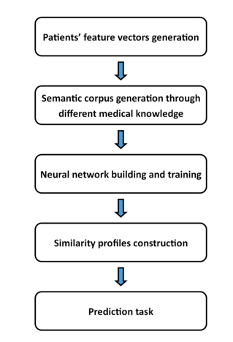  
  
  
The supervised prediction method proposed to compute discharge diagnosis similarity of patients is formulated as a sequence of steps above.   
The first step is the construction of the patient feature vectors. The second step is the development of the semantic corpus by integrating the different medical knowledge.   
The third step is the building of the neural network and its training.  
The forth step is the construction of the similarity profiles, while the final step is the prediction task.  
The similarity construction – seems like clustering using a closeness measures - like distance but of patient semantic vectors

1. **Code: yes,** in Cython, I tried to run it and I could not run it. Lots of code!
2. **Data:** unstructured, clinical notes ,heterogeneous health data from different sources, such as laboratory test results, basic information of patients, health records and social media data. The diagnosis prediction method proposed has been evaluated over a real-world medical data, the MIMIC III dataset
3. Example lines:   
   168074_Benign neo pituitary,Pneumonia, organism NOS,Acute kidney failure NOS,Panhypopituitarism,Tricuspid valve disease,CHF NOS,Hyperosmolality,Pressure ulcer, ankle,DMII wo cmp nt st uncntr,Mental disor NEC oth dis,Hypothyroidism NOS.

190301_Intracerebral hemorrhage, Food/vomit pneumonitis,Hypertension NOS,Aortocoronary bypass,Cor ath unsp vsl ntv/gft.  
  
 165393_Subendo infarct, initial,Gastrointest hemorr NOS,Aortic valve disorder,Shock w/o trauma NEC,Dehydration,Protein-cal malnutr NOS,Acute kidney failure NOS,Hypertension NOS,Periph vascular dis NOS,Crnry athrscl natve vssl.

In this paper, an artificial intelligence driven Clinical Decision Support system is proposed. The system is able to integrate heterogeneous health data from different sources, and implements a set of intelligent services exploiting innovative machine learning and deep learning approaches to support physicians in disease diagnosing and treating. In particular, the paper presented a neural network model for predicting patients’ future health information. The model is based on patients similarity in terms of symptoms and diseases. The approach employs word embedding to model the semantic relations of symptoms and diagnoses, and it introduces a mechanism to measure the semantic relationship of different diagnoses in terms of symptoms similarity for the prediction. Experimental results, performed on a real- world EHR dataset, shown that the proposed approach is effective and accurate and provides clinically meaningful interpretations.